CO2 ASSESSMENT TOOL 2 – Architecture Design Assignment
NAME: N PRAJAN SELVARAJ
REG NO: 192321071
DEPT: BTECH IT
COURSE: SOFTWARE ENGINEERING(CSA1007)

Project Title
Intelligent Nuclear Power Plant Monitoring Platform

1. Analyze System Requirements

System Objectives
The main objectives of the Intelligent Nuclear Power Plant Monitoring Platform are:
- Monitor reactor conditions in real time.
- Detect operational anomalies.
- Predict equipment failures.
- Track radiation levels.
- Support emergency response.
- Generate compliance analytics.
- Improve plant safety and operational efficiency.

Functional Requirements
- Monitor reactor temperature, pressure, coolant flow, and radiation levels.
- Collect real-time sensor data.
- Detect abnormal operating conditions.
- Predict equipment failures.
- Generate emergency alerts.
- Track radiation levels continuously.
- Generate compliance reports.
- Store historical operational data.
- Allow secure user login.
- Display monitoring dashboards.

Non-Functional Requirements

Performance
- Process real-time sensor data with minimum delay.
- Generate alerts immediately during abnormal situations.

Security
- Allow access only to authorized users.
- Encrypt sensitive plant information.

Reliability
- Ensure continuous system operation.
- Prevent data loss.

Availability
- System should be available 24×7.

Scalability
- Support additional reactors and sensors.

Maintainability
- Easy software maintenance and upgrades.

Key Quality Attributes

Scalability
Supports future expansion by adding more reactors and sensors.

Maintainability
Software modules can be updated independently.

Reliability
Provides continuous monitoring with minimal downtime.

Availability
Operates continuously throughout plant operations.

Performance
Processes real-time data with low latency.

Security
Protects sensitive operational data using authentication and encryption.

2. Select a Suitable Software Architecture

Selected Architecture
Layered Architecture

Justification
Layered Architecture is the most suitable because it separates the system into independent layers, making it easier to develop, test, maintain, and upgrade. Each layer performs a specific function while communicating only with adjacent layers. This architecture improves maintainability, scalability, and system reliability, which are essential for a nuclear power plant monitoring system.
The architecture consists of:
- Presentation Layer
- Application Layer
- Business Logic Layer
- Data Access Layer
- Database Layer

3. Draw the Software Architecture Diagram
Architecture Diagram
The architecture diagram includes:
- Users
- Presentation Layer
- Application Layer
- Business Logic Layer
- Data Access Layer
- Database
- Reactor Sensors
- External Alert Services (Email/SMS)
- Regulatory Reporting System

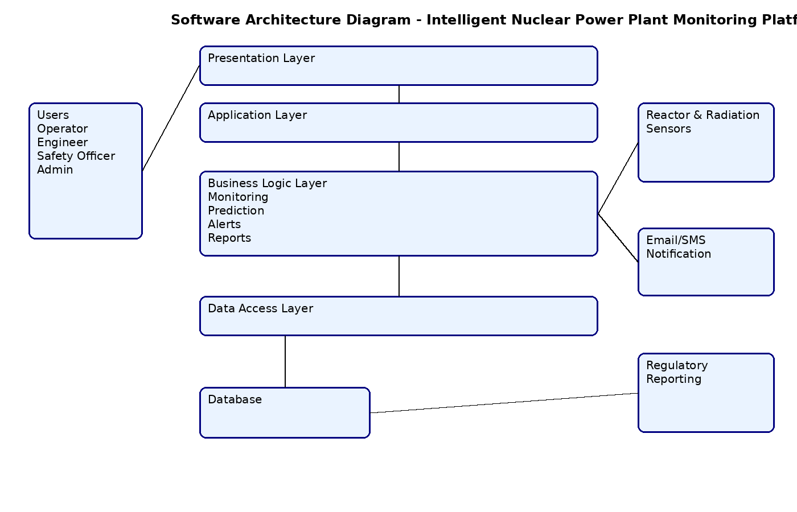
Figure 1: Software Architecture Diagram of Intelligent Nuclear Power Plant Monitoring Platform

4. Explain Components and Their Interactions

Presentation Layer
Provides the user interface for Plant Operators, Safety Officers, Maintenance Engineers, Administrators, and Regulatory Authorities.

Application Layer
Processes user requests, manages authentication, and controls communication between system modules.

Business Logic Layer
Performs:
- Reactor monitoring
- Radiation monitoring
- Equipment failure prediction
- Emergency alert generation
- Compliance report generation

Data Access Layer
Retrieves and stores operational data in the database.

Database Layer
Stores:
- Sensor data
- Reactor information
- Radiation records
- Equipment status
- User information
- Maintenance history
- Compliance reports

External Systems
- Reactor Sensors
- Radiation Sensors
- Email Notification Service
- SMS Alert Service
- Regulatory Reporting System

Component Communication
- Sensors continuously send reactor data.
- The Business Logic Layer analyzes the data.
- If abnormalities are detected, emergency alerts are generated.
- Processed information is stored in the database.
- Users access reports through the Presentation Layer.
- Compliance reports are shared with regulatory authorities.

Overall Workflow
- Sensors collect operational data.
- Data is transmitted to the Application Layer.
- Business Logic analyzes the data.
- Alerts are generated if required.
- Information is stored in the database.
- Users monitor the system through dashboards.
- Reports are generated automatically.

5. Discuss Quality Attributes

Scalability
Supports additional reactors, monitoring devices, and users without major system changes.

Security
Implements user authentication, authorization, encryption, and secure communication.

Performance
Processes large volumes of sensor data in real time.

Reliability
Ensures uninterrupted monitoring with backup and fault tolerance.

Maintainability
Layered Architecture allows independent modification of software modules.

Availability
Provides continuous service (24×7) with minimal downtime.

6. Justify Architectural Decisions

Rationale
Layered Architecture was selected because it provides clear separation of responsibilities, simplifies maintenance, improves scalability, and supports secure system development.

Trade-offs

Advantages
- Easy maintenance
- Better security
- High scalability
- Modular development
- Easier testing

Limitations
- Slight communication delay between layers.
- Additional implementation complexity.

Future Enhancements
- AI-based predictive maintenance.
- Cloud-based backup.
- Mobile monitoring application.
- IoT integration.
- Advanced analytics dashboard.

Long-Term Maintainability
The layered design allows future software updates, new sensors, and additional monitoring modules to be integrated without affecting the entire system.

